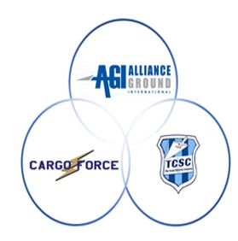

CONSENT AND RELEASE TO COLLECT, USE AND STORE BIOMETRIC IDENTIFIERS AND/OR INFORMATION

During the course of your employment, AGI-CFI Acquisition Corp. and subsidiaries (the “Company”) may, from time to time, collect, use and/or store information from you that may qualify as a biometric identifier or biometric information – including, information collected from your hand, fingerprint and/or finger scan, face print and/or face scan, voice print and/or scan, iris scan, and/or retina scan. The Company collects, stores and uses this information to comply with federal laws and regulations, to administer its timekeeping system, which is administered by certain vendors, including Workday, Inc. (“Workday”) and/or ZKTechnology, LLC (“ZKTeco”), and for the maintenance of time and attendance records associated therewith. Workday and/or ZKTeco will maintain the timekeeping database which might include information qualifying as biometric identifiers or biometric information. The Company, Workday, and ZKTeco will collect, use and/or store such information for the duration of your employment, and unless further retention is required by law (such as federal laws and regulations, a valid warrant, subpoena or litigation hold notice), it will be permanently destroyed when the initial purpose for collecting or obtaining such information has been satisfied or within three (3) years of your separation from employment, whichever occurs first.

Please note the Company, Workday, and ZKTeco exercise reasonable care in storing, protecting and/or transmitting information that might qualify as biometric identifiers and/or biometric information and do so in manner that is the same or more protective than the manner in which they protect other confidential and sensitive information. The Company, Workday, and ZKTeco will not sell, lease, trade, or otherwise profit from your potential biometric identifiers or biometric information. Absent your consent or unless required by law (such as federal laws and regulations, a valid warrant or subpoena), the Company, Workday, and ZKTeco will not disclose or disseminate such information to third parties.

**Acknowledgment of Employee’s Receipt and Understanding**

I have received a copy of this Consent and Release to Collect, Use and Store Biometric Identifiers and/or Information. I understand it is my responsibility to read this consent or have it read to me and that if I have questions about the Company’s collection, use and storage of potential biometric identifiers or information, I will notify the Company’s Human Resources Department. A copy of the Company's Policy Governing Collection, Usage and Retention of Biometric Identifiers and/or Information is available upon request and is posted at www.allianceground.com.

By signing this policy I am confirming that I have received this policy and understand it, and voluntarily consent, to the Company, its subsidiaries and/or its Vendors' actions above.

Signature Date

Printed Name